Program No.: 5

Create a package my package, which has class to represent a bank account, includes following data members: Name of the depositor, account no, type of account and balance amount.

**Main file**:

import MyPAck.Bank;

import java.util.Scanner;

public class Account

{

public static void main(String args[])

{

Scanner sc = new Scanner(System.in);

int choice;

long ac;

String nm;

double amt, id;

System.out.println("Enter A/C No., Name and Initial Deposit:");

ac = sc.nextLong();

nm = sc.next();

id = sc.nextDouble();

Bank b1 = new Bank(ac, nm, id);

while (true)

{

System.out.print("Menu\n1. Deposit\n2. Withdraw\n3. Display\n4. Exit\n Enter your choice: ");

choice = sc.nextInt();

switch (choice)

{

case 1: System.out.print("Enter the amount to be deposited: ");

amt = sc.nextDouble();

b1.deposit(amt);

break;

case 2: System.out.print("Enter the amount to be withdrawn: ");

amt = sc.nextDouble(); b1.withdraw(amt);

break;

case 3: b1.display();

break;

case 4: sc.close();

System.exit(0);

default: System.out.println("Invalid choice. Try again");

}

}

}

}

**Package file:**

package MyPAck;

public class Bank

{

long acc_no;

double balance;

String name;

public Bank(long a, String n, double bal)

{

acc_no = a;

name = n;

balance = bal;

}

public void deposit(double amt)

{

balance += amt;

System.out.println("Your balance is: " + balance);

}

public void withdraw(double amt)

{

if (balance - amt > 1000)

{

balance -= amt;

System.out.println("Your balance is: " + balance);

}

else

{

System.out.println("Insufficient balance");

}

}

public void display()

{

System.out.println("Account No: " + acc_no);

System.out.println("Name of the customer: " + name);

System.out.println("Balance: " + balance);

}

}

Output: 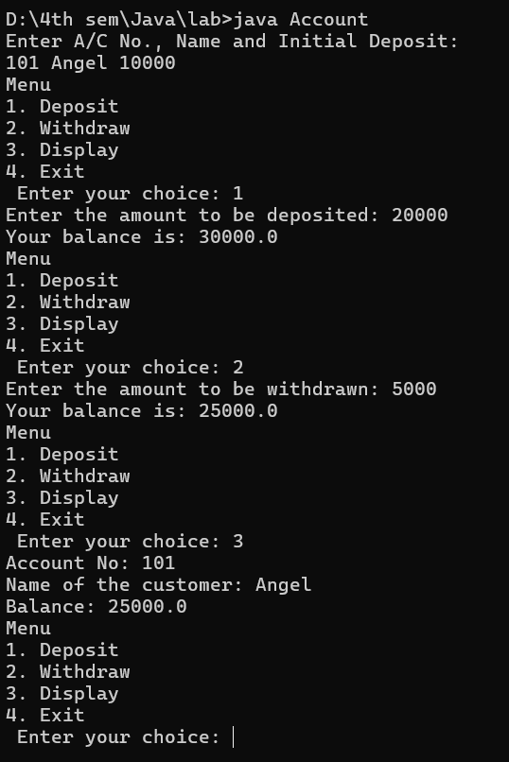

Program No.: 6

Write a java program to demonstrate the usage of feature package. Create package to convert temperature in centigrade into Fahrenheit and one more package to calculate simple interest. Implement both packages in main.

**Package file 1:**

package tempconvert;

import java.io.*;

import java.util.Scanner;

public class Convertor

{

public void cent_fahren()

{

double f = 0, c= 0;

Scanner b = new Scanner(System.in);

try

{

System.out.print("Enter the temperature in Centigrade: ");

c = b.nextDouble();

}

catch (Exception e) {}

f = (c * 9) / 5 + 32;

System.out.println("The temperature in Fahrenheit is: " + f);

}

public void fah_cent()

{

double f = 0, c = 0;

Scanner b = new Scanner(System.in);

try

{

System.out.print("Enter the temperature in Fahrenheit: ");

f = b.nextDouble();

}

catch (Exception e) {}

c = (f - 32) * 5 / 9;

System.out.println("The temperature in Centigrade is: " + c);

}

}

**Package file 2:**

package calculate;

import java.util.Scanner;

public class SimpleInterest

{

float p, n, r, si;

public void getdata()

{

Scanner b = new Scanner(System.in);

try

{

System.out.print("Enter Principal: ");

p = b.nextFloat();

System.out.print("Enter Time in Years: ");

n = b.nextFloat();

System.out.print("Enter the Rate of Interest: ");

r = b.nextFloat();

}

catch (Exception c) {}

}

public void process()

{ si = (p * r * n) /

100;

}

public void putdata()

{

System.out.println("The Principal Amount: " + p);

System.out.println("The Number of Years is: " + n);

System.out.println("The Rate of Interest is: " + r);

System.out.println("Simple Interest is: " + si);

}

}

**Main file:**

import tempconvert.*;

import calculate.*;

public class Calculation

{

public static void main(String args[])

{

Convertor c = new Convertor();

SimpleInterest s = new SimpleInterest();

System.out.println("Output for Temperature:");

c.cent_fahren();

c.fah_cent();

System.out.println("\nOutput for Simple Interest:");

s.getdata();

s.process();

s.putdata();

}

}

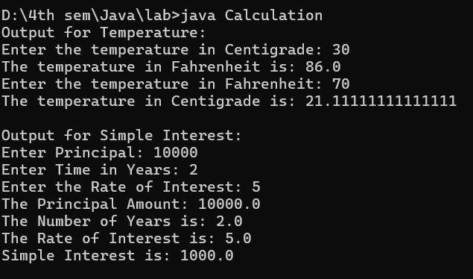

Program No.: 7

Program to demonstrate multithreading using runnable interface. Define three different threads one to calculate square of first n integers, another to calculate cube of first n integers and third thread to find the square root of the first n integers.

import java.util.Scanner;

class Square implements Runnable

{

int n, i;

Square(int no)

{

n= no;

}

public void run()

{

for (i = 1; i <= n; i++)

{

System.out.println("Square of " + i + " is " + i * i);

}

}

}

class Cube implements Runnable

{

int n, j;

Cube(int no)

{

n= no;

}

public void run()

{

for (j = 1; j <= n; j++)

{

System.out.println("Cube of " + j + " is " + j * j * j);

}

}

}

class SquareRoot implements Runnable

{

int n,k;

SquareRoot(int no)

{

n = no;

}

public void run()

{

for (k = 1; k <= n; k++)

{

System.out.println("SquareRoot of " + k + " is " + Math.sqrt(k));

}

}

}

public class RootThread

{

public static void main(String args[])

{

try

{

Scanner b = new Scanner(System.in);

System.out.print("Enter any number: "); int

n = b.nextInt();

Square s = new Square(n);

Cube c = new Cube(n);

SquareRoot q = new SquareRoot(n);

Thread t1 = new Thread(s);

Thread t2 = new Thread(c);

Thread t3 = new Thread(q);

System.out.println("Start Thread t1");

t1.start();

System.out.println("Start Thread t2");

t2.start();

System.out.println("Start Thread t3");

t3.start();

b.close();

}

catch (Exception e) {}

}

}

Output:

